
ACCESSIBILITY

Microsoft Dynamics Snap
Business Data Lookup Snap-in
For Microsoft Dynamics™ CRM 3.0 / 2007 Microsoft® Office system
Technical White Paper

February 10, 2007

Microsoft Dynamics Snap Sandbox

Table of Contents
EXECUTIVE SUMMARY 3
INTRODUCING MICROSOFT DYNAMICS SNAP 3
MICROSOFT DYNAMICS SNAP FOR BUSINESS DATA LOOKUP 3
FUNCTIONAL OVERVIEW 5
FIND THE BUSINESS DATA YOU NEED 5
BROWSE BUSINESS DATA 8
ATTACH OFFICE DOCUMENTS TO MICROSOFT DYNAMICS CRM DATA 9
HIGH LEVEL ARCHITECTURE 10
PRE-Requisites for using this Snap-in 12

EXECUTIVE SUMMARY
Many corporations implement business application systems like Microsoft Dynamics™ to automate their business processes. However, in order to accomplish what is required of their jobs, many employees tend to spend most of their time using the Microsoft Office® suite of applications. Although those workers can and do benefit from direct access to relevant business data, there are times when it would be much more productive for them to be able to obtain that information from within the Microsoft Office application in which they are working. What if there were ways to enable those information workers to access the data in Microsoft Dynamics applications from within Microsoft Office?

INTRODUCING MICROSOFT DYNAMICS SNAP
Microsoft Dynamics Snap applications do just that—they allow information workers to interact with Microsoft Dynamics business information, thereby increasing their productivity and enabling them to make decisions with confidence, all from within the Microsoft Office applications they are most comfortable with and with which they are most familiar. Now all employees can get timely and accurate data out of or into the Microsoft Dynamics applications without ever having to leave Microsoft Office. Microsoft Dynamics Snap applications help companies maximize their investment in Microsoft technology by delivering the power of the Microsoft Dynamics business applications to every single employee.

MICROSOFT DYNAMICS SNAP FOR BUSINESS DATA LOOKUP
The Business Data Lookup Snap-in enables an Information Worker to look for information in Microsoft Dynamics CRM™3.0 from within 2007 Microsoft® Office system applications. Using a task pane launched within Microsoft Word®, within Microsoft Excel® or within an email in Microsoft Outlook®, the Information Worker can
- Search for records like accounts, contacts, quotations, etc.
- View details of these records
- Browse data related to a particular record, e.g. all quotations made to a particular customer
- Select and copy data into the document
- Attach the document to a selected record in Microsoft Dynamics CRM for reference
Surfacing the data from Microsoft Dynamics CRM in the Office environment has many benefits. It helps:
- Minimize costly duplication of effort and errors in data entry
- Create a streamlined user experience, increasing productivity by eliminating the need to switch programs or interrupt someone else’s workday to get access to information
- Decrease training costs as the Microsoft Dynamics Snap applications are very simple and intuitive to use
- Improve decision making by providing access to real-time data

Phase 1 and 1.5 releases of the Business Data Lookup Snap-in worked with Microsoft Dynamics CRM 3.0 and Microsoft Office 2003 and were distributed under the Microsoft Permissive License at the Dynamics Snap site on GotDotNet.com. Microsoft partners and customers are encouraged to extend and customize these applications as well as to use their components within applications they have developed. The Phase 2 release has been upgraded to work with Microsoft Dynamics CRM 3.0 and the 2007 Microsoft Office system.
This white paper is divided into two sections, the first to help you understand the features of the Business Data Lookup snap-in and the second to help you use the technology to customize your own solutions:
- Functional Overview: This section explains the Business Data Lookup Snap-in functionality.
- High Level Architecture and Customization: This section explains the various technologies used and how they work together. Partners may use a similar framework to build additional scenarios.

FUNCTIONAL OVERVIEW
Most business users spend a large part of their time working in the Microsoft Office environment. Yet, completing simple and frequent tasks like browsing business data, inserting business information into documents, and attaching documents to Microsoft Dynamics CRM data requires them to toggle back and forth between applications which can be time consuming and can lead to errors. This decreases productivity.
The Business Data Lookup Snap-in allows business workers to search and browse Microsoft Dynamics CRM data from within the Microsoft Office environment (Word, Excel or Outlook) using the Microsoft Office task pane. They can also copy data into Microsoft Office documents and attach Microsoft Word or Microsoft Excel documents to Microsoft Dynamics CRM records.
The next few screenshots demonstrate how easy it can be for users to view and insert data from Microsoft Dynamics CRM while working in the familiar Microsoft Office environment. As an example, consider a scenario where you are creating a quotation and you wish to refer to an earlier quote as you fill in data for this quotation.

FIND THE BUSINESS DATA YOU NEED
In a Word document, an Excel spreadsheet, or while composing an Outlook e-mail message, all you need to do is click Insert From CRM button in the BDL – CRM 3.0 section under the Snap tab of the ribbon to launch the Business Data Lookup - CRM task pane. This allows you to browse Microsoft Dynamics CRM data by choosing the entities you wish to search in the Look In field, typing the text you wish to search for in the Look For field, then clicking the Search button, , in the task pane. In the scenario mentioned above, to get information regarding the quote you previously made to the customer, you will select customer as the entity and enter first few characters of his name in the Look For field.
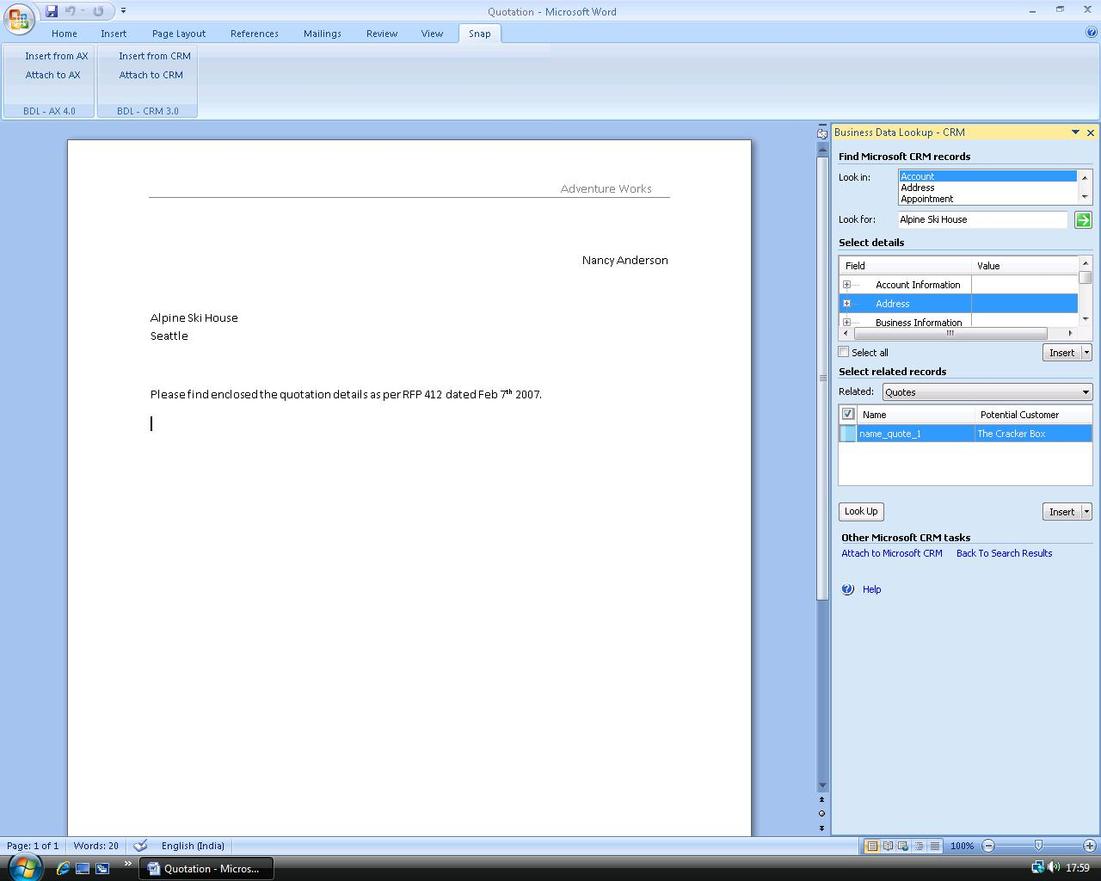
You can also right-click any word or phrase in a Microsoft Word or Microsoft Excel document and search for it in Microsoft Dynamics CRM using the context sensitive Search in CRM menu item. This menu item invokes the Business Data Lookup task-pane with the Look For field filled with the selected text. The search results are displayed in the Record Details section of the task pane, grouped by entity names.
View Record Details
To view the details of the records returned by the search, double click the record. This opens the record in the detailed view with all the fields shown. In case of the customer record you searched for, the detailed information will show the fields of a customer record from Microsoft Dynamics CRM, like address, phone, contact person, etc.
Copy Data into the Document
You can copy data shown in the task pane to your Microsoft Office document. To do this, select the fields you wish to insert into the document from the Select Details section and click Insert. The selected records will be copied to your Office document as simple text. You can also insert data as a table by choosing Insert as table option of the Insert split button. In the scenario mentioned above, you can insert the address details of the selected customer into the quotation document by selecting the data and clicking insert.
View and Insert Data Pertaining to Related Records
To look for and insert data pertaining to records that are related to the record you selected, find the relation you wish to explore from the Related drop down and then select one or more records from the list of related records on the Business Data Lookup - CRM task pane and insert the fields that you want to add into the document. This will, for example, help you look up all quotations made to the customer by selecting ‘Quotations’ in the Related drop down and in a single click, copy details as a neatly formatted table into the document. You can now create the new quote by editing the values entered in the previous quote.
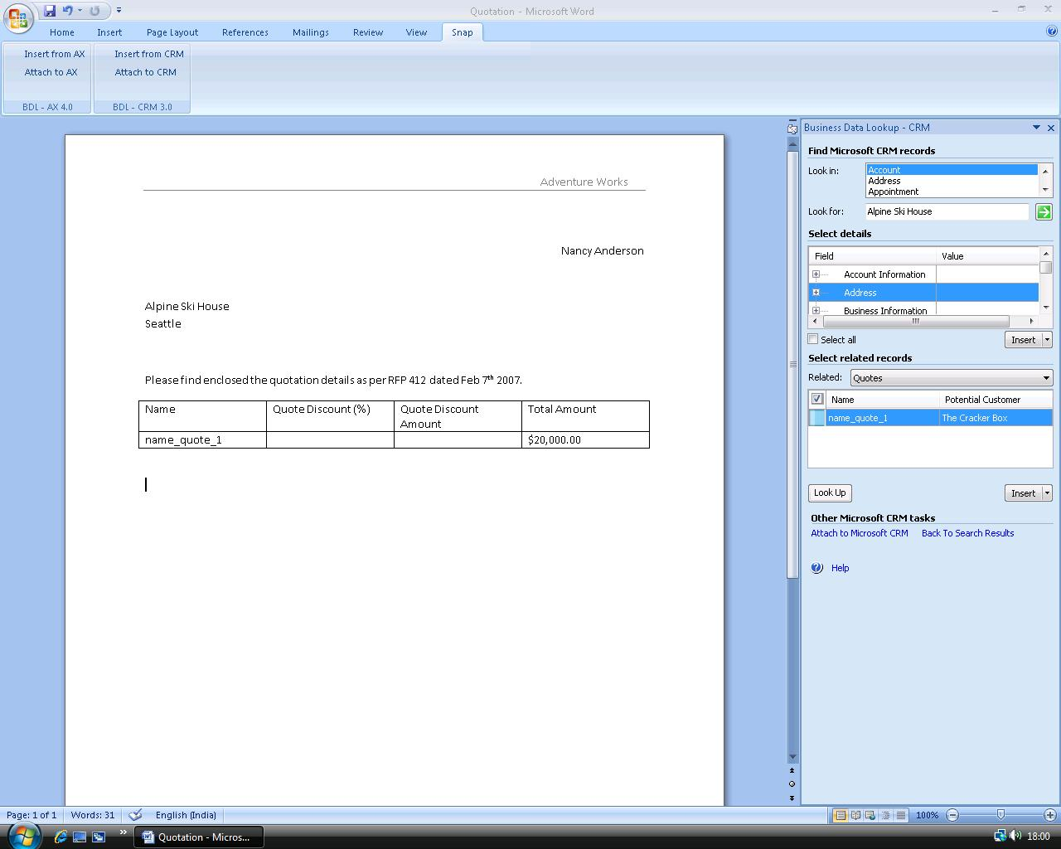

BROWSE BUSINESS DATA
You can browse the hierarchy of related entities by promoting the related record as the primary record and then viewing its details or other entities related to it in the same task pane. To do so, select a related record and click Look Up. The selected related record will become the top level entity and the details and related records that appear will pertain to the newly promoted entity. This will allow you to drill down to view more details of the quote you are interested in. For example, you can promote the quotation you selected as primary entity and then insert details about the quote product for each item comprising the quotation by selecting Quote Products in the Related drop down.

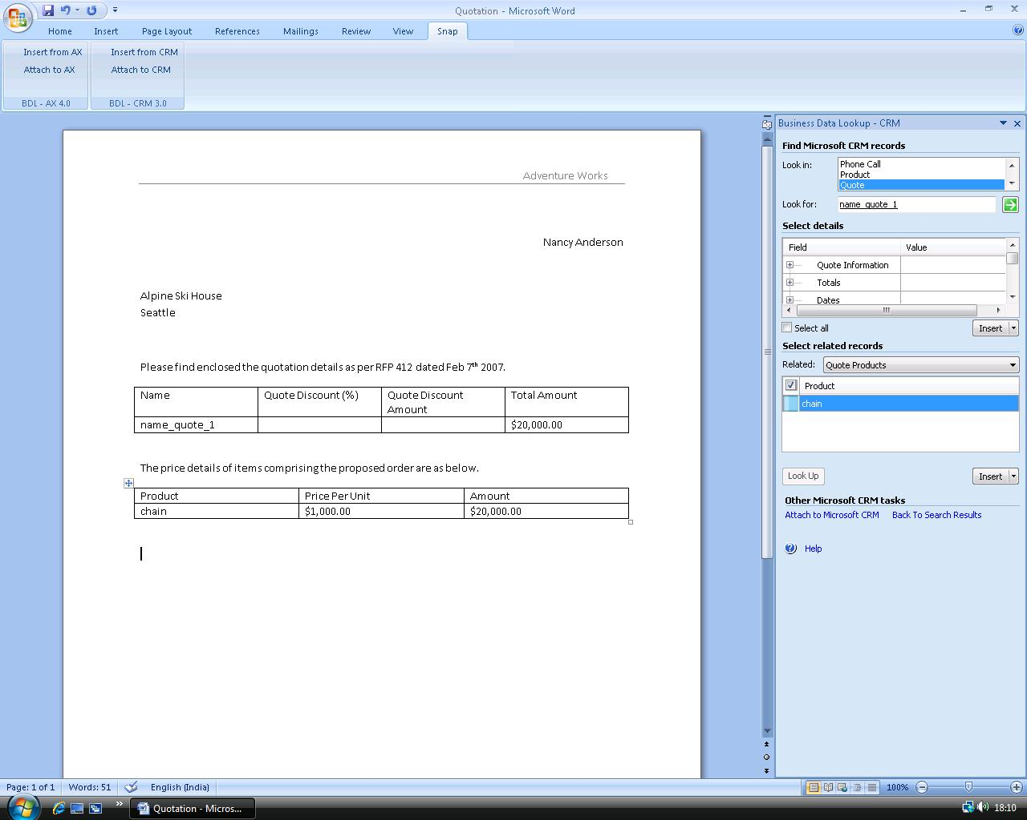

ATTACH OFFICE DOCUMENTS TO MICROSOFT DYNAMICS CRM DATA
You can attach documents to a Microsoft Dynamics CRM record without leaving the Microsoft Word or Microsoft Excel document that you are working in (this option is not available in Outlook). To do this, while you are in Word or Excel, click on the Attach to CRM button on the Ribbon to bring up the Business Data Lookup – CRM task pane. If the task pane is already visible you may click on the Attach to CRM link that is provided under the Other Microsoft Dynamics CRM tasks section. Browse to the record of your choice, choose the record to attach document to, and click Attach. The document will be attached to the Microsoft Dynamics CRM record in the ‘Details’ pane. You can also specify the attachment type before attaching the document.
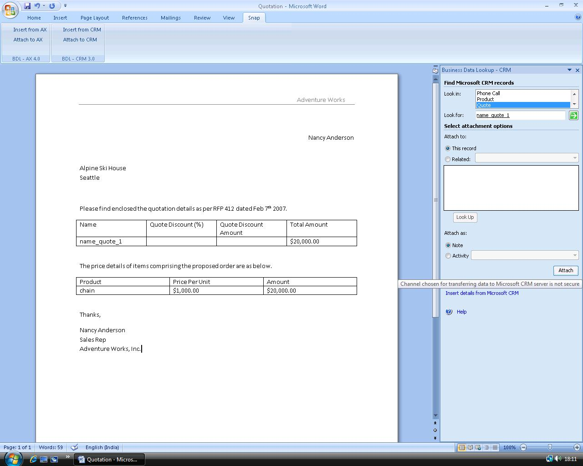

HIGH LEVEL ARCHITECTURE
The solution uses Microsoft Visual Studio 2005 Tools for Office (VSTO) system. The VSTO system includes projects for two main types of solutions. Microsoft Office Word 2007 and Microsoft Office Excel 2007 projects can be used to build document-level solutions, in which a managed code assembly is attached to a Word document or Excel workbook. Microsoft Office Outlook 2007 projects can be used to build application-level solutions, in which a managed code assembly runs as an add-in in Outlook.

Software Requirements for Running the Application
- Microsoft Outlook 2007
- Microsoft Word 2007
- Microsoft Excel 2007
- Microsoft Dynamics CRM 3.0
- Microsoft .NET 2.0 - Runtime
- Microsoft Visual Studio 2005 Tools for Office Runtime - SE

Components in the Application
DLL Name | DLL Description | Application
CRMBDLExcel.dll | DLL for excel add-in | Business Data Lookup for Excel
CRMBDLOutlook.dll | DLL for Outlook add-in | Business Data Lookup for Outlook
CRMBDLWord.dll | DLL for Word add-in | Business Data Lookup for Word
CRMInstallLibrary.dll | DLL used by setup | Setup
CRMScenarios.dll | DLL for outlook user control | Business Data Lookup for Outlook
ExpandableGridView.dll | DLL for Entity Details Grid user control | Common among all three add-ins
ResFixer.dll | DLL for resolving certain resource strings | Common
collapsiblecontrol.dll | DLL for showing collapsible panels | Common

Architecture Diagram

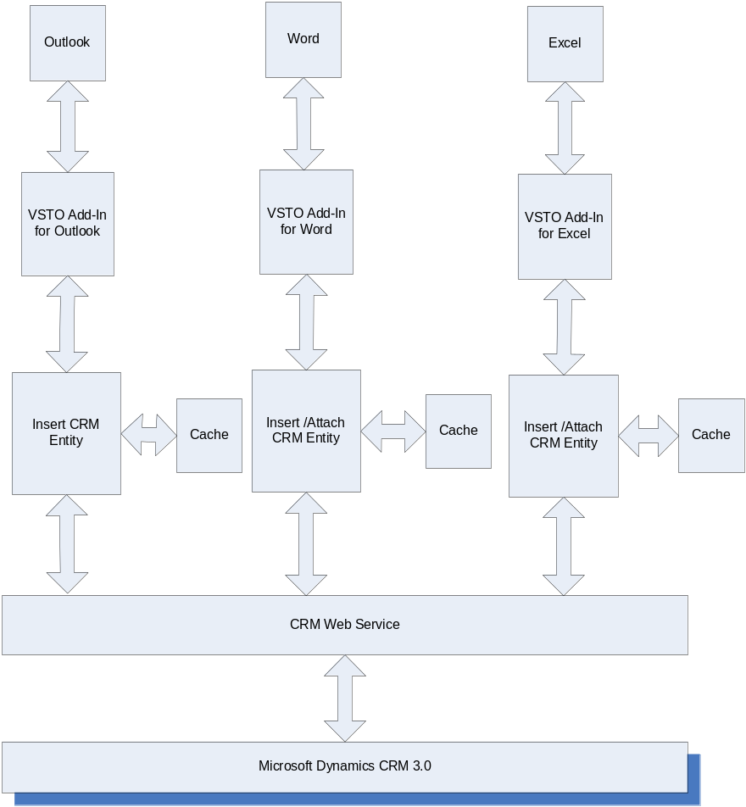
The installation of VSTO 2005 SE runtime and Business Data Lookup Snap-in creates the required DLLs, application manifests and registry entries that allow the target Microsoft Office application (Word/Excel/Outlook) to recognize it as a valid COM add-in. The Office application loads the add-in during startup. On loading, the add-in creates the context menus and ribbon items. When Business Data Lookup Snap-in is launched to insert or attach CRM entities by clicking the respective Snap ribbon tab or from the context menu, it initializes and creates a custom task pane and a connects to Microsoft Dynamics CRM web service specified during setup. To logon to Microsoft Dynamics CRM web service, the snap-in uses the cached credentials in the system. The add-in then initializes its metadata from Microsoft Dynamics CRM web service and surfaces it in the task pane. When a user looks up details in the task pane, data access logic in the task pane user control queries the Microsoft Dynamics CRM web service using the methods exposed by it, retrieves and displays the required information. The custom task pane uses the object model of the calling application to interact with the open office document, insert data from the task pane into the document or to attach the document to Microsoft Dynamics CRM using the web service.

PRE-Requisites for using this Snap-in
- Microsoft Office 2007 should be installed, along with all the latest updates, and Microsoft Outlook should have been run at least once on the local machine
- The user should be a local admin on the machine and should have permissions and access to the Microsoft Dynamics CRM 3.0 server
- Microsoft .NET Framework 2.0 should be installed on the system
- Microsoft VSTO 2005 SE Runtime should be installed on the system
For more details on the pre-requisites and configuration requirements, please refer the installation guide in the setup package.

The information contained in this document represents the current view of Microsoft Corporation on the issues discussed as of the date of publication. Because Microsoft must respond to changing market conditions, this document should not be interpreted to be a commitment on the part of Microsoft, and Microsoft cannot guarantee the accuracy of any information presented after the date of publication.
This White Paper is for informational purposes only. MICROSOFT MAKES NO WARRANTIES, EXPRESS, IMPLIED, OR STATUTORY, AS TO THE INFORMATION IN THIS DOCUMENT.
Complying with all applicable copyright laws is the responsibility of the user. Without limiting the rights under copyright, no part of this document may be reproduced, stored in or introduced into a retrieval system, or transmitted in any form or by any means (electronic, mechanical, photocopying, recording, or otherwise), or for any purpose, without the express written permission of Microsoft Corporation.
Microsoft may have patents, patent applications, trademarks, copyrights, or other intellectual property rights covering subject matter in this document. Except as expressly provided in any written license agreement from Microsoft, the furnishing of this document does not give you any license to these patents, trademarks, copyrights, or other intellectual property.

© 2006 Microsoft Corporation. All rights reserved.
Microsoft, the Microsoft Dynamics Logo, 2007 Microsoft Office System, BizTalk, Dexterity, FRx, Microsoft Dynamics, SharePoint, Visual Basic, Visual C++, Visual SourceSafe, Visual Studio, Windows, and Windows Server are either registered trademarks or trademarks of Microsoft Corporation, FRx Software Corporation, or Microsoft Business Solutions ApS in the United States and/or other countries. Microsoft Business Solutions ApS and FRx Software Corporation are subsidiaries of Microsoft Corporation.
Microsoft Dynamics is a line of integrated, adaptable business management solutions that enables you and your people to make business decisions with greater confidence. Microsoft Dynamics works like and with familiar Microsoft software, automating and streamlining financial, customer relationship and supply chain processes in a way that helps you drive business success.

www.microsoft.com/dynamics

